Lab 14

1.  
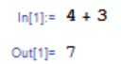

2.  
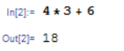

3.  
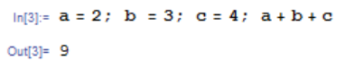

4.  
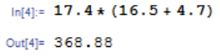

5.  
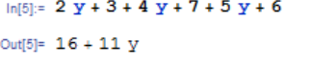  
6.  
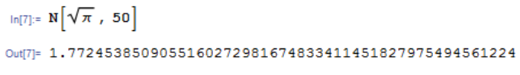

7.  
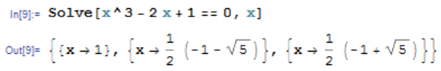

8.  


9.  
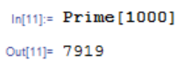

10.  
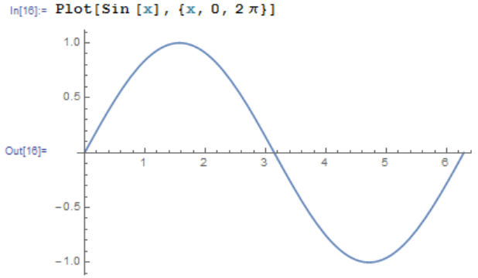  
11.  
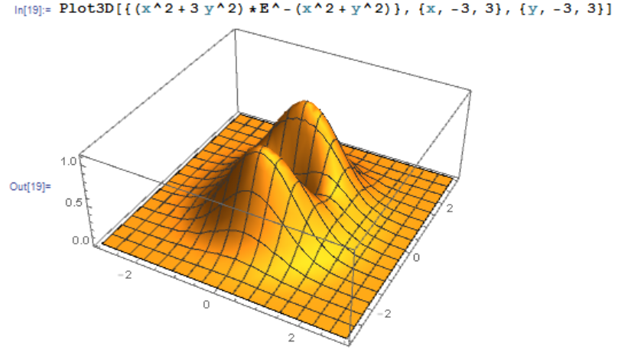

12.  
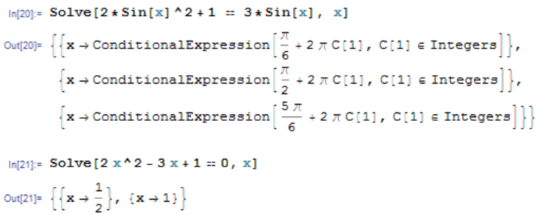

13.  
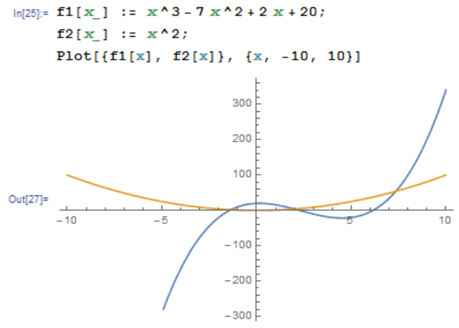  
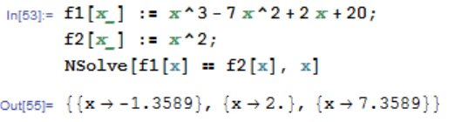

14. 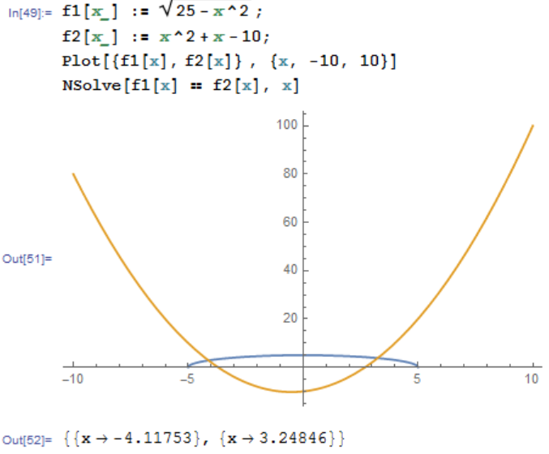

15.  
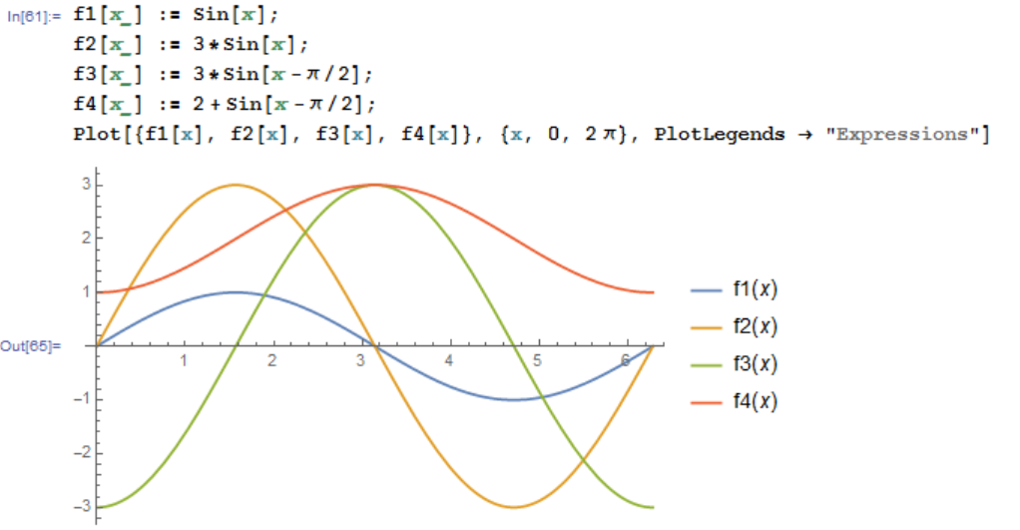

|  |  |  |  |  |
| --- | --- | --- | --- | --- |
|  | Amplitude | Period | Phase Shift | Vertical Shift |
| F1 | 1 | 2π | 0 | 0 |
| F2 | 3 | 2π | 0 | 0 |
| F3 | 3 | 2π | π/2 | 0 |
| F4 | 1 | 2π | π/2 | 2 |

16.  
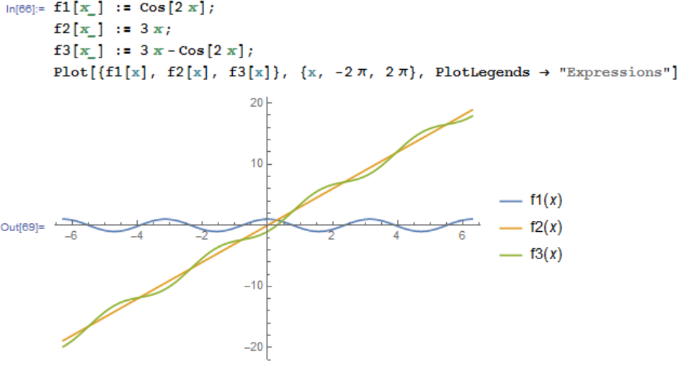

17.  
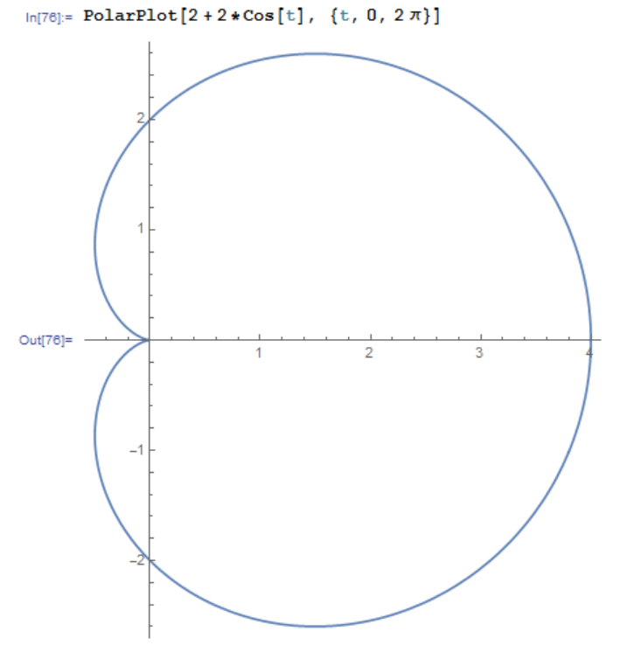

18.  
